82.03.06
From Eugene Fitzalan
RB MSS M8, Library, Royal Botanic Gardens Melbourne.

Willow Vale Bowen March 6th 1882
The Baron von Mueller.

Dear Sir
When I received your telegram I suspected that the specimens I sent you must have got damaged and was afraid I might be too late as the season for cones was nearly over, and our wet season had fairly set in it was raining heavily when I got your telegram on Wednesday and rained all thursday & Friday on Saturday it cleared a little and on Sunday morning I resolved to act on a suggestion you once threw out with regard to Mount Elliott viz — To make a dash for it — so I started on Sunday morning and camped among the Cycas late that night the distance being about 50 miles = In the morning to my dismay I found that since my last trip the Black's had been there gathering their usual Harvest of the Cycas fruit and had burned the Country for miles and that the Cycas leaves were all hanging down dead & brown many having fallen off altogether and this made matching the cones far more difficult as it was mostly by the leaves I was guided; and only the cones on the tallest trees had escaped scorching and to get some of these without breaking them was difficult and there was hardly a nut to be found as the Blacks do their harvesting most effectually — — — I rode miles trying to find a patch that had escaped the fire but in vain — it had been burned before the rain, and had not been burned the year before so it swept every thing before it — I got however 4 cones 2 of Normanbyana and one each of the two other species and I believe I have matched them correctly, I have dried them and sprinkled them with Kerosene and carefully sowed them up in mosquito net and put nothing in the box with them except a few well dried wood shavings which do not readily heat or decay and I think this time they will reach you safely I send some young rachis with the ovules and some full grown fruit on the rachis by which you will see, that where the ovules do not all swell into fruit their place and number are clearly shown, on the rachis thus Normanbyana will sometimes have only one full grown and one abortive nut, but I do not think it ever shows 3 or 4, and media may have only 2, 3 or 4 nuts but it will always show the places of at least 6 and sometimes 7 or 8 = of no 2 which you have kindly named after me I send good rachis with fruit ripe and rachis with the ovules only formed off two different trees — and you can see no trace of more than 4 fruit on each = it is not until you get well up among the mountains that the two species which bushmen designate "Curly" from the peculiar appearance which the curved frond gives them is found no 2 appearing even more so than no 1 from the second upward curve of the frond 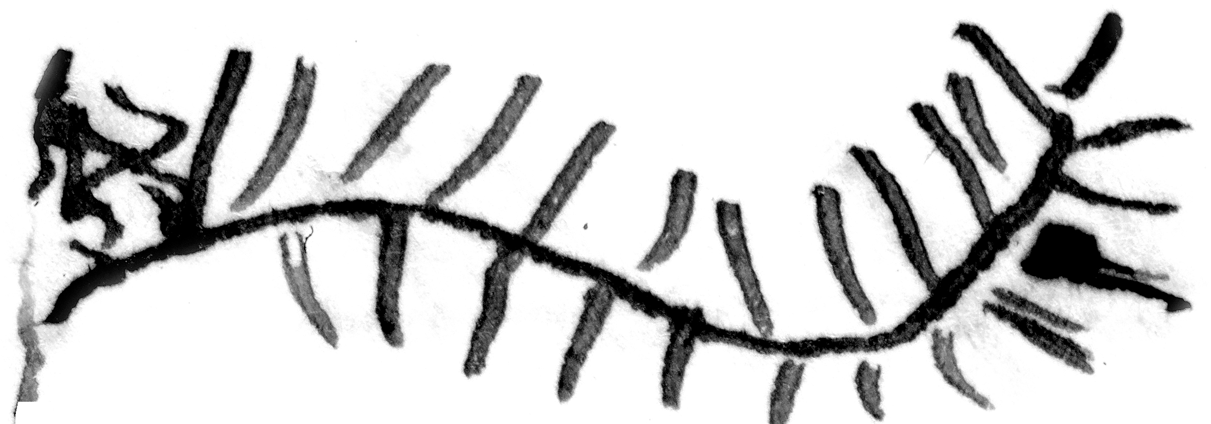 In this one the frond is not near so long in proportion to size of stem — as either of the others and the stem of several that I noticed lately appear to be more massive at the butt and thicker at the Top than either of the others, But this may be accidental, The stems that I have shipped away to Goldie & others might have a few no 1 amongst them but not likely no 2 — They would mostly be good specimens of media (no 3) as for the sake of carriage I got them as low down the ranges as possible and then it was 40 miles and very difficult to get at with teams
The Normanby ranges commence about 40 miles from Bowen in a southerly direction; on the highest portion of them 60 miles from Bowen the Normanby diggings are situated a reefing field of considerable extent which has been abandoned owing to the hardness of the sinking and most of the reefs though rich were narrow — and though some of them gave 2 oz & more to the ton miners said it did not pay and it is now deserted; these ranges are about 30 miles long by about 10 to 15 wide E & W — and the whole of this space is covered with Cycas in countless thousands I may even say millions the stems of them were used for building Humpies & for slabbing shallow shafts on the Diggings being more plentiful than any timber
The ranges are all Grey Granite except just on the diggings where they strike a hard blue Rock at 30 to 40 feet though the surface even there shows Granite Boulders —
I know of no Zamia nearer here than the neighbourhood of Peak Downs which I believe is their most northern boundary they extend from there south into New South Wales in Isolated patches — being most plentiful I believe near Springsure I never saw but one species (Spiralis) with fruit of an irregular oblong square — I have frequently had the fruit sent me from Springsure;
I mention this because when camped at a station about 60 miles west from Bowen one of the young gentlemen showed me what I took to be a Zamia nut made into a match box; he said it was a Cycas and came from somewhere near the Barcoo (SW) it was oval shaped like a Cycas nut but more than twice the size being about 2 inches long by about 1¼ in wide with the texture of Zamia seed rather than Cycas — and beatifully polished He declined to part with it —
With regard to Macrozamia Denisonia or M. Hopeii or Katakidozamia I know nothing except what I saw on the Daintree and it appeared to be identical with M Denisonia that I had seen just previously in the Botanic Garden Sydney — and this must have been Mr Hills Catakidozamia as there was no other large Cycad either on the Daintree or Mossman or any of the Rivers in Trinity Bay and I saw a good deal of the Country much more than any other Collector I found these macrozamias or whatever they are from the size of ones fist up to 12 or 14 feet high and a foot thick I found one with a cone of fruit but as it was only half grown I did not take it — I brought away a lot of young ones — I enclose sample of leaf of small plant — — I would like to have about £50 to spend on collecting between Cardwell and Cooktown I could do more now for £50 than any one could have done 4 or 5 years ago for three times that amount as there is now more or less of settlement on all the Rivers and I would know exactly how to get about and where to go — and any thing that I could not get at the time of my visit I would point out to some resident to get for me at the proper time — But though I would like such a trip I could not make it pay — and it is hard to get about new country without money —
Our resident photographer is at present in England perfecting himself in the business but will be back in May — when it will be possible to get Cycas views on reasonable terms —
yours faithfully
Eugene Fitzalan

Catakidozamia
Cycas media
Cycas Normanbyana
Macrozamia Denisonia
Macrozamia Hopeii
Zamia Spiralis

MS annotation by M: 'Gum of Cycas Answ 22/3/82'. Letter not found.
Qld.
Telegram not found.
No cycad named by M after Fitzalan has been identified (IPNI, accessed 13 February 2022). In B82.03.01, M named Cycas Kennedyana, collected in the Normanby Ranges by Fitzalan, in honour of Sir Arthur Kennedy, the Governor of Qld.
The sentence ends as shown.
beautifully?
Macrozamia denisonii?

